**Capstone Project Review Snapshot**

1. HTML Lint Error Snapshot

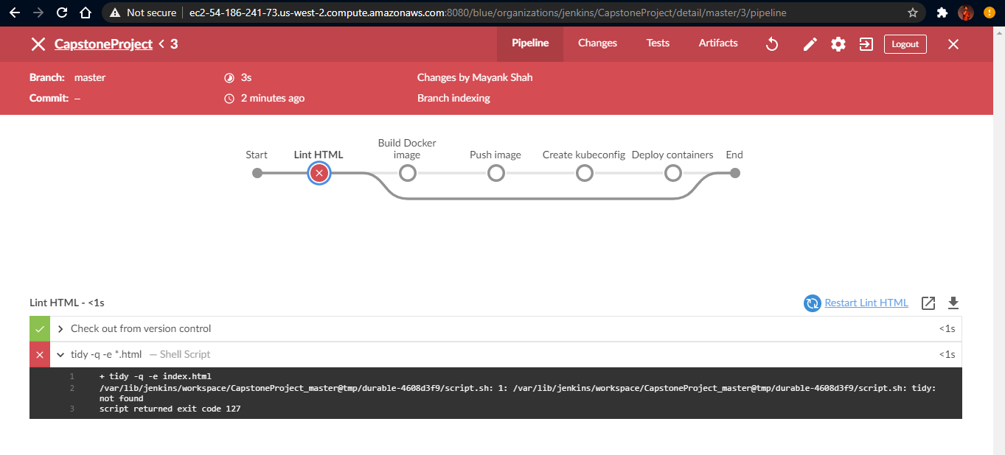

1. Lint Success & Jenkins Pipeline Successful Deployment Snapshot

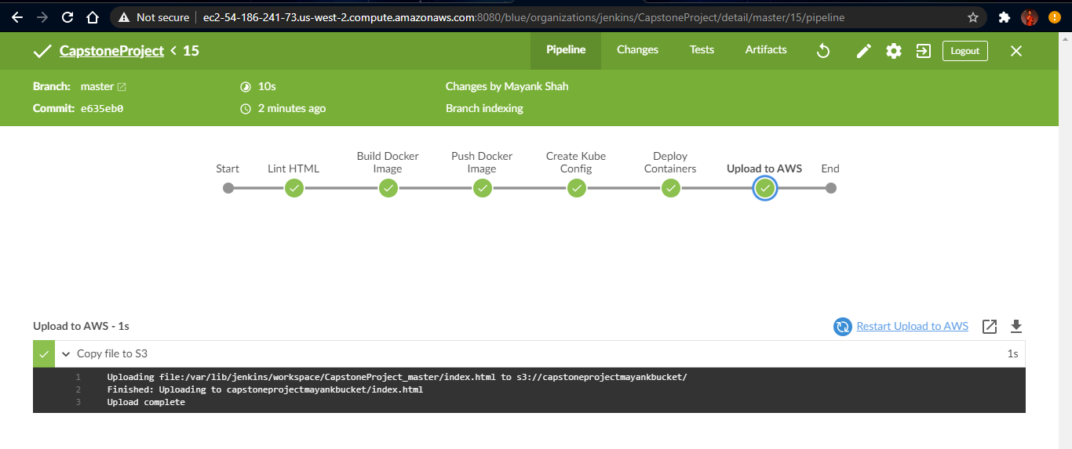

1. AWS EC2 Host & EKS Node Instances Snapshot

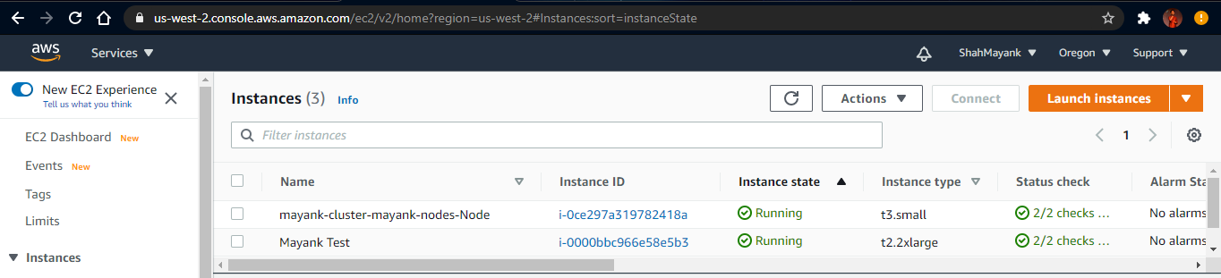

1. EKS Details Snapshot

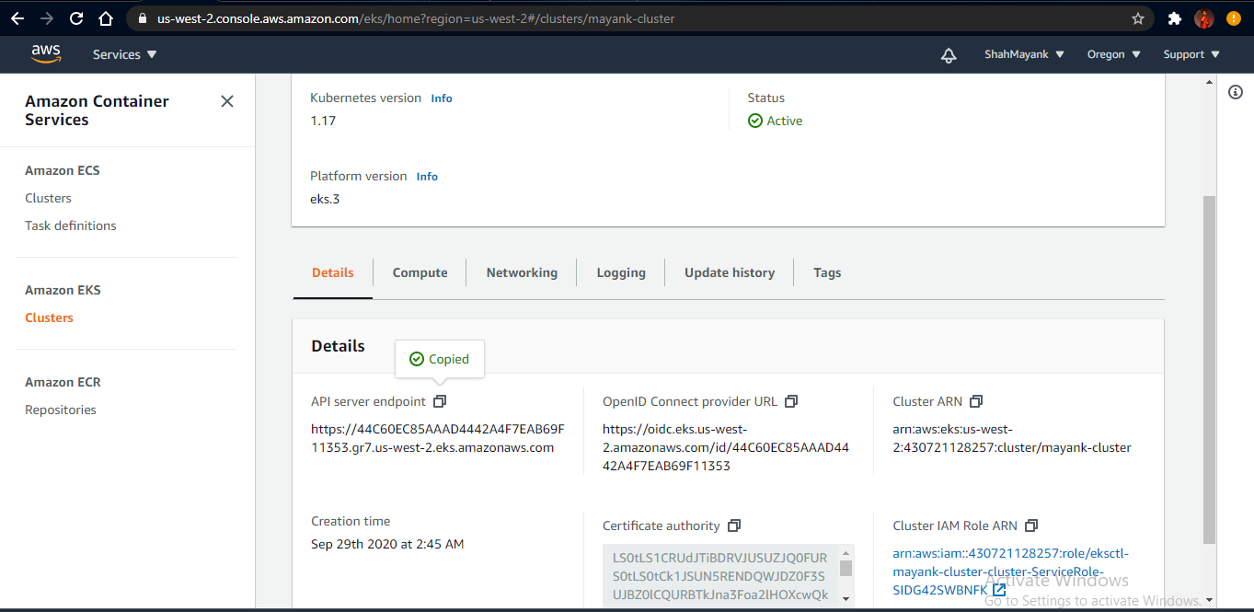

1. ECR Details Snapshot

